**Using My Chart through Hennepin County Public Health Clinic**

**The Hennepin County Public Health Clinic offers My Chart through Hennepin Healthcare**

MyChart offers you personalized and safe online access to parts of your health records. It lets you safely use the Internet to get facts about your health. With MyChart, you can:

* View your health summary.
* View test results.
* Ask for prescription renewals.
* Communicate online and safely with your health care team.

[MyChart Frequently Asked Questions - Hennepin Healthcare](https://www.hennepinhealthcare.org/mychart-frequently-asked-questions/)

**Initial Registration**

Patients who wish to participate will be issued a MyChart activation code through an email during registration for their clinic visit. This code will enable you to log in and create your own username and password.

**Can’t remember your username or password?**

Go to the My Chart website (https://mychart.hcmc.org/MyChart/authentification/login?) or the My Chart app, select Forgot Username or Forgot Password.

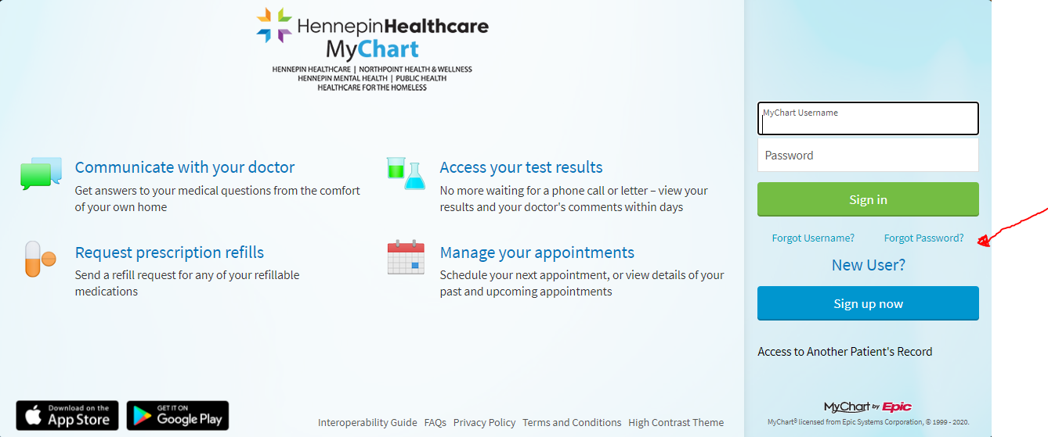

**Mobile access through My Chart App**

You can also access My Chart from your phone or tablet by downloading the app through Apple App Store or Android Google Play Store. Choose Hennepin Healthcare.

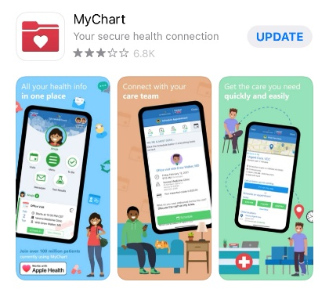

Questions about My Chart?

* hennepinhealthcare.org/mychart
* Email [MyChartSupport@hcmed.org](mailto:MyChartSupport@hcmed.org)
* Call MyChart Patient Support Line at [612-873-5600](tel:612-873-5600)

How do I sign up?

Patients who wish to participate will be issued a MyChart activation code during their clinic visit. This code will enable you to log in and create your own username and password. If you were not issued an activation code, you may call your primary care clinic to get one or ask to sign up during your next office visit.